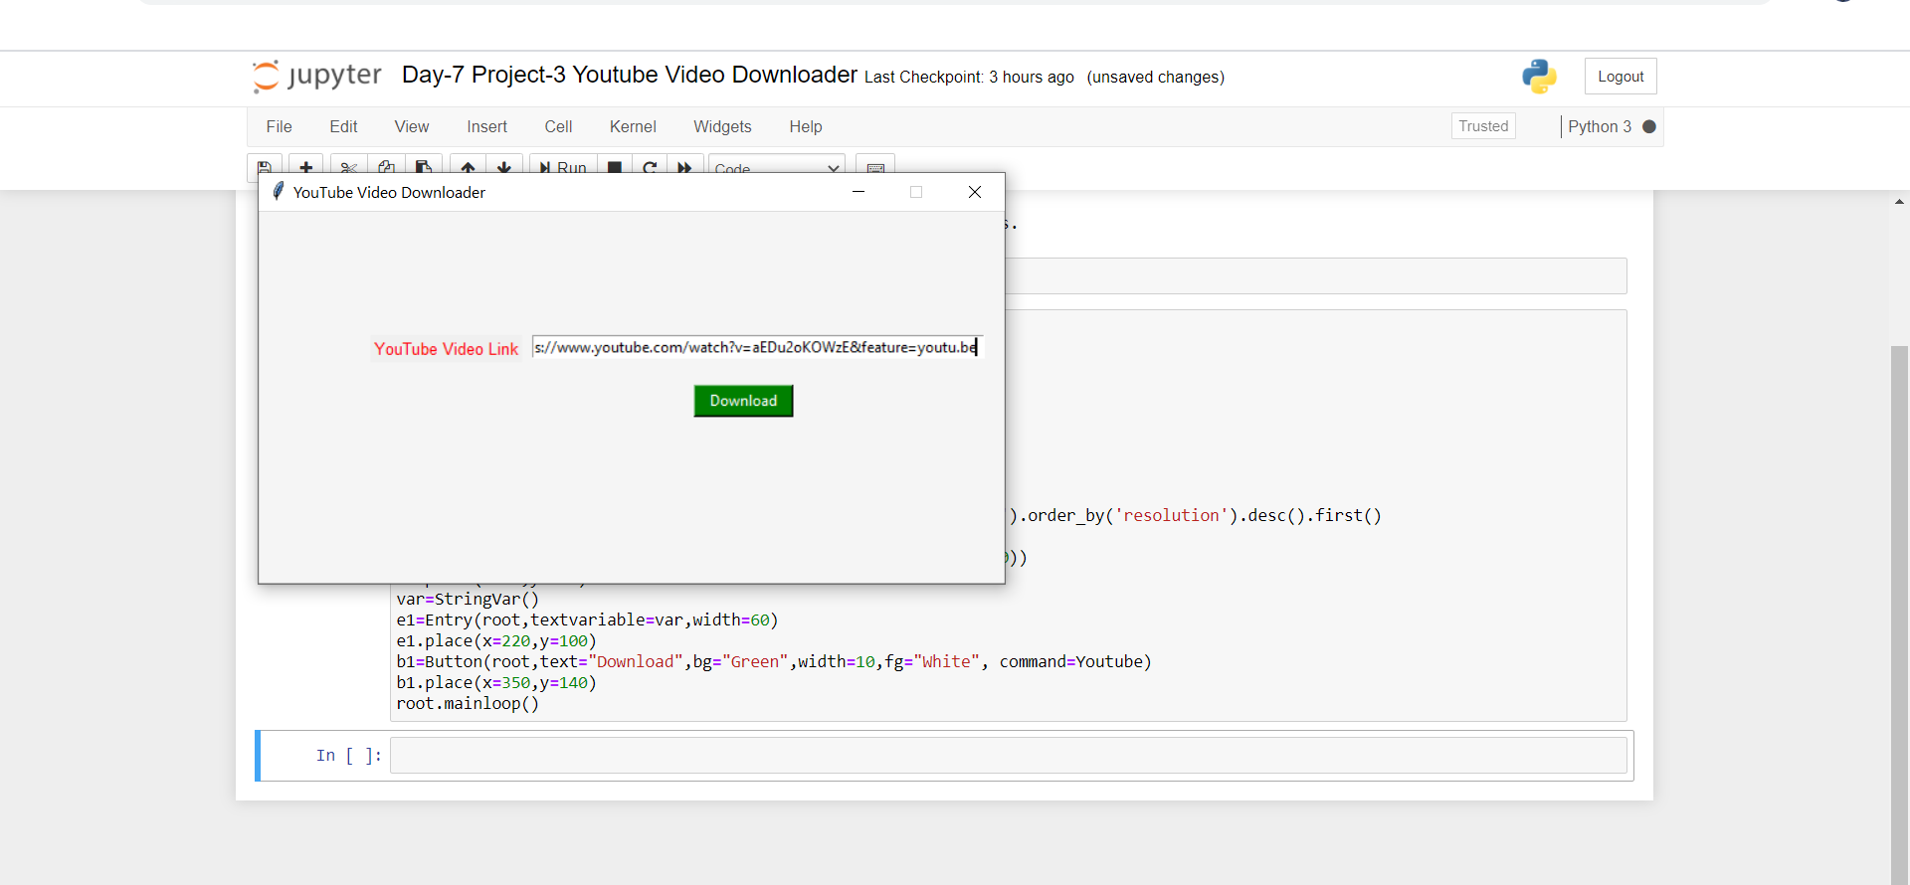

Fig shows gui for python video downloader

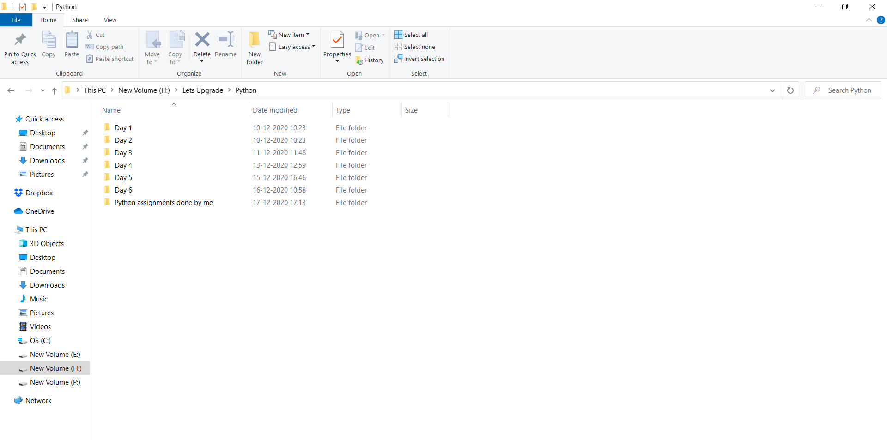

Fig shows folder before clicking download button.

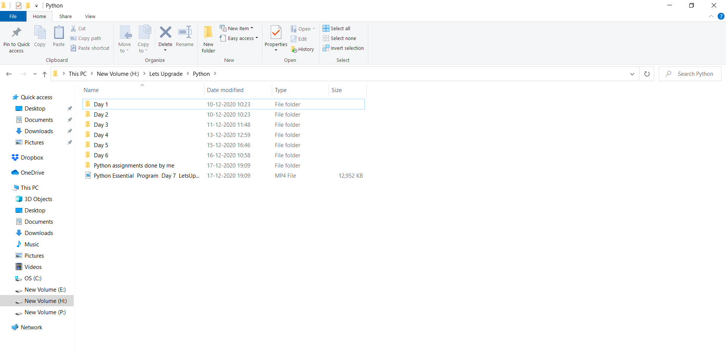

Fig shows download folder after clicking download button.

Note:-you can see that, a video has downloaded, in the above picture.